Abstract:
In this document we cover the major and some of the detailed functionalities of Streamix. We also review its architecture and a specific development methodology called DRPM that is developed specifically for Streamix customization. The main objective of the combination of its architecture and development methodology is to reduce the cost and time-to-market for any ERP project that uses Streamix as its core engine.

Functionality Overview

Introduction:

Streamix is designed based on the next generation of ERP system, where traditional ERP merges with CRM, SCM and E-Commerce. Taking advantages of the latest technologies on distributed computing such as Web Services & J2EE and developing based on the state of art framework such as service oriented architecture (SOA), Streamix is a product to answer the fast pacing need of the ERP from mid size to large scale enterprises.

The following is the list of major Streamlet functionalities:

Quote to Cash
Quote to Cash covers the business process for creating a quote for a prospect or customer, order management, invoicing, and cash receipt. The functionality is highly integrated with Supply Chain Management and Customer Management. In traditional systems, you find this in modules like order entry and accounts receivable.

Requisition to Pay
Requisition to Pay covers the business process for creating requisitions, purchase order, invoice receipt, and payment processing. The functionality is highly integrated with Supply Chain Management. In traditional systems, you find this functionality in modules like purchasing and accounts payable.

Customer Relations Management
Customer Relations Management is not an independent module, but the logical view of all customer and prospect related activities. Customer management functions are an integrated part of the business process. Therefore, there are (in contrast to traditional CRM systems) no batch or synchronization processes for the back-office functionality.

Partner Relations Management
Partner Relations Management links different clients to each other allowing them to manage lead distribution, service requests, collateral distribution, and marketing expenses. It also allows you to provide (centralized) services.

Supply Chain Management
Supply Chain Management covers all material management activities including inventory receipts, shipments, moves, and counts within a client and its organizations and to suppliers and customers.

Performance Analysis
Performance Analysis covers the costing and accounting dimension of the application. In traditional systems, you find this functionality in Reporting and General Ledger, modules as well as in those modules that generate accounting entries.

Web Store
The Streamix Web Store provides all you need to run your web presence. The information is shared with the standard application, so no synchronization or extra integration work is required. The web store components can be customized to the look-and-feel of your web site.

Why is it organized like that?
Business processes rather than traditional departments drive Streamix design. In today’s world, and especially in small-medium enterprises, people often cover entire business processes or even multiple related processes.
Here is a mapping chart as guidance:
Traditional Module | Quote to Cash | Requisition to Pay | Customer Management | Partner Management | Supply Chain | Performance Analysis
General Ledger |  |  |  |  |  | x
Accounts Payables |  | x |  |  | x | x
Accounts Receivables | x |  | x |  |  | x
Purchase Order |  | x | x |  | x | x
Sales  Order | x |  | x |  | x | x
Inventory Management | x | x | x |  | x | x
Fixed  Assets |  |  |  |  |  | x
CRM | x |  |  |  | x

Quote to Cash

Quote to Cash covers the business process for creating a quote for a prospect or customer, order management, invoicing and cash receipt. The functionality is highly integrated with Supply Chain Management and Customer Management. In traditional systems, you fund this in modules like order entry and accounts receivables.

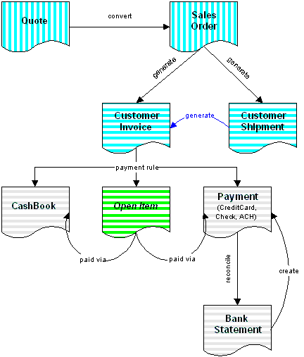

Quotes
Create and print customer quotes based on general or customer price lists. Quotes can be “binding”, which reserves inventory. You can change a quote any time and convert it to a Sales Order.

Sales Orders
Sales Orders are the “fulfillment control document”. Sales Orders generate Shipments and Invoices and make sure that the order is fulfilled (For details see: Order Processing).

Shipments
Based on your Sales Order, you can generate one or more shipments immediately or automatically when inventory available (automatic backordering).

Customer Invoices
Invoices are generated either immediately based on your Sales Order or based on Shipments. You can choose to create an Invoice immediately after each Shipment, when the order is completely shipped or based on a Customer Invoice Schedule. An Invoice Schedule allows you to send summary invoices, e.g. for your shipments at the end of the week, month, etc.
You can also enter invoices manually.

Receipts
When entering the Order or Invoice, the payment rule allows you to automatically generate receipts:
- Create a Cashbook entry for petty cash transactions
- Create a Payment for direct payments (Credit Card, Check, eCheck, Automatic Clearing House). Streamix supports merchant payment processors via VeriSign PayFlowPro; other payment processors are planned.
Open Items are settled by creating Payments (e.g. receiving a Check or creating a Direct Debit), creating a Cashbook entry (e.g. open invoice paid by petty cash later) or when reconciling Bank Statements (e.g. bank transfers).
For details see Open Item Management, Cash Journal

Bank Statement
Bank Statements can be entered or automatically loaded. You reconcile your in-transit payments, enter charges or create payments for direct transfers.

Requisition to Pay

Requisition to Pay covers the business process for creating requisitions, purchase order, invoice receipt and payment processing. The functionality is highly integrated with Supply Chain Management. In traditional systems, you find this functionality in modules like purchasing and accounts payables.

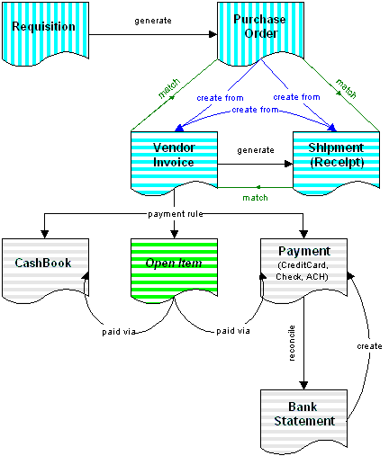

Requisitions
Create requisitions manually or automatically via Material Replenishment. Approve your requisitions to generate purchase orders.

Purchase Orders
Generate and consolidate purchase orders from approved requisitions. Material Replenishment can also directly create Purchase Orders. Transmit your purchase orders directly via EDI, per email or per fax.
Streamix supports two-way and three-way matching. Purchase Orders are automatically closed minimizing overhead.

Material Receipts
Receive your material and directly create (and match) the shipment from your Purchase Order (or Vendor Invoice).

Vendor Invoices
Directly create (and match) your invoice from Purchase Orders or Receipts. You can also create receipts automatically from your invoice when you receive your invoice and shipment at the same time.

Payments
Create payments based on payment terms taking advantage of payment discounts. You can create Automatic Clearing House transactions and transfers or use check-printing programs. You can also pay by credit card and record this when entering the Purchase Order or Invoice.

Bank Statement
Bank Statements can be entered or automatically loaded. You reconcile your in-transit payments, enter charges or record your direct debit payments

Customer Relations Management

Customer Relations Management is not an independent module, but the logical view of all customer and prospect related activities. Customer management functions are an integrated part of the business process. Therefore, there are (in contrast to traditional CRM systems) no batch or synchronization processes for the back-office functionality.

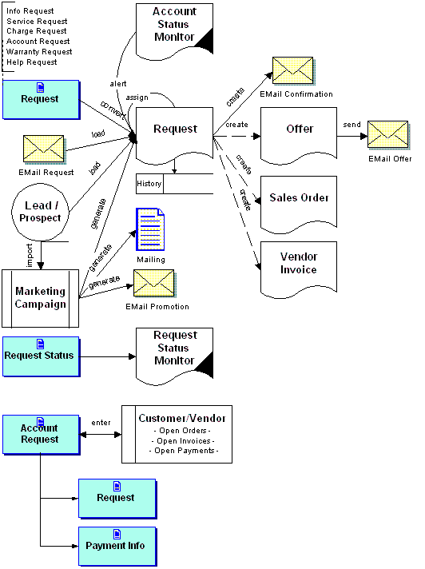

Lead and Activity Tracking
Streamix supports the following types of requests
- Information – (un)structured requests from web or email sources
- Service – structured request to perform a service at a given time & place
- Charge – structured request to reimburse costs
- Account – structured request concerning a particular customer or vendor order, shipment, invoice or payment
- Warranty – structured request concerning a product or service issue
- Help – structured customer service request
Depending on the type, the request can be automatically converted to a target document (offer, order, invoice). A confirmation email with tracking number can be sent manually or automatically. Requests can be assigned to particular system users
With the tracking number, the creator can update information. Management facilities ensure timely response and closure.
Requests can also be generated based on the account status (date last sale, overdue payment, etc.) for customer service or sales to follow up.

Marketing Campaign Management
Customer retention is a crucial mission for every company. Streamix supports this by creating mailings or requests for the (tele) sales force to follow up. Criteria for campaign could be last sale, sales volume, products purchased, etc.
To attract new customers, addresses of prospects can be imported for mailings or requests for the (tele) sales force to follow up.
The effectiveness of marketing campaigns can be measured by the revenue or gross profit generated.

Customer Profitability Analysis
You can report on revenue and gross profit of specific customers or customer groups over a period of time.

Self Service Online Inquiry
All business partner contacts can be enabled to view their information and status. They then can create information or account request to initiate follow-ups … or pay open items.

Partner Relations Management

Partner Management links different clients to each other allowing them to manage lead distribution, service requests collateral distribution and marketing expenses. It also allows providing (centralized) services.

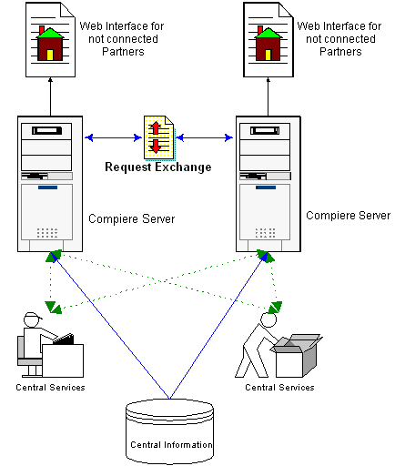

Relationship Management Across Servers
Basically, Partner Relations Management provides Customer Relations Management functionality across Streamix clients/companies. For not connected Partners information is tracked via a web interface. Streamix exchanges the requests automatically for connected Partners.

Lead Distribution and Tracking
Create leads and distribute them to your partners. You can follow up and monitor progress and results.

Marketing Expense Accounting
Enable your partners to create charge invoices directly.

Collateral Ordering
Enable your partners to order collaterals automatically.

Customer Service Requests & Warranty Requests
Initiate and follow up Service Requests and manage warranty requests.

Shared Services
Provide Services for your Partners (Accounting, Help desk, Shipping, etc.). As a Service Provider, you get access to just the information, you need for your tasks – but across organizations and clients, so that you can do your job effectively.

Centrally Maintained Information
For your partners, you can maintain central data like Products, Price Lists or Accounting Information. Partners can add additional entities, but cannot change the central maintained elements for consistency.

Supply Chain Management

Supply Chain Management covers all material management activities including inventory receipts, shipments, moves and counts within a client and its organizations and to suppliers and customers.

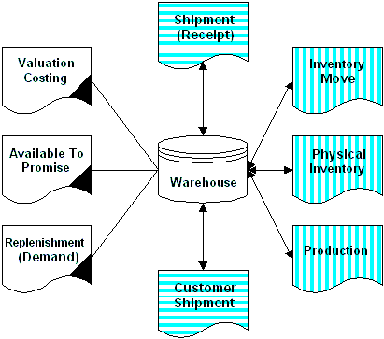

Product Catalog
Define your Product and Services with optional Bill of Materials and Substitutes. Import and update purchase prices from your vendor.
Organize your products in product categories and hierarchies. You can also search by product attributes.
You may have multiple price lists for purchases and sales. Purchase price lists allow you to control discounts and outstanding credits from your suppliers. You may have general and customer specific sales price lists. Price lists are date controlled to allow special sales initiatives.

Distribution & Multi-Warehouse Control
Manage your inventory by organizing your warehouses into user-defined locations. Move inventory between warehouse and take physical inventory.

Materials Management
Create Customer Shipments in batches or individually per order. Control Vendor Receipts by comparing it directly with the purchase order or the vendor invoice.
Know what is Available to Promise considering reservations for future customer shipments and expected vendor receipts – Optionally on a time scale.
Generate Material Replenishment lists based on past sales or targeted inventory levels; optionally create Requisitions or directly Purchase Orders.

Product/Service Costing
Maintain your product and service costs.

EDI Integration
Automatically check product availability with your vendors and transmit purchase orders to your vendors directly.

Performance Analysis

Performance Analysis covers the costing and accounting dimension of the application. In traditional systems, you find this functionality in Reporting and General Ledger modules as well as those modules that generate accounting entries.

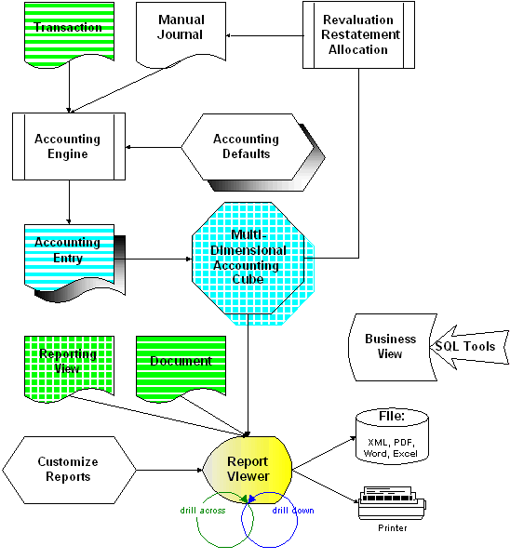

Accounting Rules
Accounting entries are automatically generated based on rules. This allows also for manual entries to generate additional postings (actual, statistical, etc.). For details see Information Structure or Accounting.

Integrated Reporting, Data Warehousing and OLAP
From every document in the system, you can create reports. You can define the layout, sorting, labels, etc. to customize it for your all or a specific organization or for yourself. Reporting Views enable analytical and summary reporting.
The reporting facility, you can drill down to contained elements (e.g. from order to business partner, payment rules, etc.) or drill across to referenced items (from order to invoices, shipments, etc. linked to that order).
For multidimensional entries, you can select the dimensions where you want to report on.
All information can be printed or exported to Excel, Word, XML, PDF, etc. for further processing. Secure Business Views allow you to extend the reporting to external dedicated SQL based reporting tools.

Manual Journals
The majority of accounting transactions are generated. This allows you to report your transaction in multiple accounting schemas. Manual journals allow you to create accounting entries for a specific accounting schema. This is usually only used for correcting accounting entries.

Generated Journals
The system allows you to generate journals for
- Allocations
- Revaluations
- Restatements

ECommerce (Web Store)

The Streamix Web Store provides all you need to run your web presence. The information is shared with the standard application, so no synchronization or extra integration work is required. The web store components can be customized to the look-and-feel of your web site.

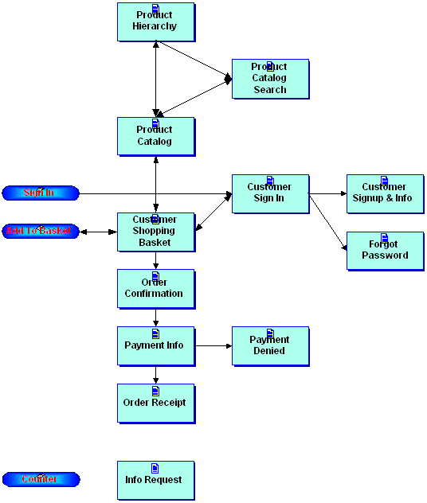

Online Product Catalog
View and search the your product catalog. Product images can be displayed, if the product has an image attachment. You can restrict the products available on the web.
You can define (multiple) hierarchies to limit product selection. You can also search by Product Category or Product Attributes.

Online Pricing and Availability
You can choose, if you want to show product availability (either as “available” or the actual quantity). If the user is logged in as a Business Partner Contact with a specific price list, these prices are shown; otherwise the default price list is shown.

Online Sales Transactions
Add items to the Shopping Basket via the Product Catalog or web form request. You can change quantity or delete items.
When checking out, you can make it mandatory to sign in to retrieve stored customer information. For the Confirmation, applicable shipping costs and tax is calculated. The payment information is entered or confirmed. Currently, the VeriSign payment processor is supported. Before submitting you can verify the credit card number for data entry errors.
After receiving the payment confirmation, the order is created and the receipt is displayed. Optionally an email can be sent with the receipt.

Supporting Components

User Management
You can store user information and enable cookies to allow automatic detection and sign in.

Counter
You can monitor web requests and collect information like referring page, client host, time, user (when signed in), etc.

Info Requests
A web user request can be forwarded to one or more email address. You can also send a confirmation to the requester. The request becomes part of the Customer Relations Management.

Functionality Detail

Introduction:
We covered the major functionality of Streamlet in the previous chapter, however knowing some of the detailed functionality of Streamlet, help you to identify how easy one can customize Streamix to match specific needs of a company and how one can leverage some of these functionality to extend the domain of a company to a much larger global customers. Some of these functionalities belong to one module (for example Bill of Material that belongs to Supply Chain Management) and some are cross modules (Such as Data Import). It is important to know that this chapter doesn’t cover all of the Streamix functionalities, where adding more functionality and upgrading the previous ones is an ongoing effort in the life of Streamix.

Information Structure

Streamix has an advanced information structure allowing structural changes in midstream breaking the limitations of the old fashioned Set of Books system used by competitors.

Structural changes midstream
After an application is in production or even during implementation, users often request changes in the information structure. There are many reasons for change requests. During the use of the application, people realize that information is not needed or information is required for decision-making. Also, changes in the business may require the collection of additional information.
Most applications do not allow any change or a change requires the same effort as implementing it from scratch.
Streamix allows the user (not an IT expert) to add, change or delete information dimensions at any time. The underlying OLAP (Online Analysis Processing) structure is maintained automatically.

Information Dimensions & Trees
Streamix provides an extensive list of predefined dimensions:
- Organization
  - Owning (balance sheet organization)
  - Transacting (executing organization or service center)
- Natural Account
- Date & Time
  - Transaction
  - Accounting
- Product
- Product Category
- Business Partner
- Project
- Marketing
  - Channel
  - Campaign
- Location (Warehouse, Business Partner)
  - From
  - To
- Activity (for activity based costing)
Streamix allows the user to define additional dimensions. These dimensions can be validated via lists or table lookups.
There is no overhead, if a dimension is not used.
All dimensions allow the definition of Trees. These summary levels allow reflecting the organization structure or the balance sheet and income statement positions.
Changes within the tree structure are possible at any time.
Every information dimension has a primary tree and can have additional summary trees. This may be required if you want to maintain the ‘old’ and ‘new’ structure for comparison - or if you need different parallel business partner hierarchies, e.g. one by Industry, another by Type (wholesale, retail, consumer).
Many applications do not have the ability to structure information dimensions, which results in unnecessary data entry and overhead. Example: if you want information on branch and division levels and divisions are made up of branches, you may have to enter the two fields branch and division and define rules, so that users cannot enter a wrong branch for a given division and vice versa.

Automatic Data Collection
Data entry needs to be as efficient as possible, which is equivalent to entering as few fields as possible. Streamix provides a framework, which derives information automatically from the transaction context. Users can also select choices.
This is a significant advantage over other applications. For example, usually the Order Entry functionality is not ‘aware’ of the information needs of Customer Relationship functionality, this results in information that is not available or needs to be derived from existing data with subsequent loss of required detail.
Getting the information right from the source is a tremendous benefit. But, if the information is not needed, the user is not asked.

Combination of Dimensions
For reporting purposes, the user can slice and dice any combination of information dimensions. For all transactions the source and accounting currency information is maintained in addition to unit of measure and quantity.
You can view your financial results by Business Partner and Region or Product Group and time of day.

Where is my Book?
An Accounting Book is often defined as the combination of Chart of Accounts, Calendar, Currency, with implied accounting rules. Streamix broadens that definition, storing the information on the lowest granularity. The traditional reporting is then just a summary level.
The information required for a business decision is often not found in traditional accounting systems, so additional data warehousing systems maintain parallel data to accommodate this need. Streamix is based on a data warehousing architecture to allow flexible reporting.
Let’s use the time dimension as an example. In Streamix, the detail for each transaction is stored. Therefore, transactions can be summarized in any way necessary, by hour of day, weekday or traditional accounting calendar period.
Streamix maintains both, the accounting and transaction date. This is required for revenue recognition rules of service contracts or if the costs were for another period (next year’s rent). If you need to account using different accounting principles (e.g. accrual and cash based), the accounting periods can be different. You can report using either view.
This bottom-up approach also allows meeting the Italian, French and Latin-American accounting requirements without artificial constructs. As the generation of accounting lines is rule based, no superfluous accounting lines are generated like in other applications. Streamix makes the accounting easy to understand and reconcile. It even reconciles differences between disparate accounting methods (e.g. cash and accrual based or using different costing methods).
The summarized views are generated dynamically based on reporting needs using Materialized Views for performance.

For the Global Market

Today’s marketplace - even for smaller business - is becoming global. You may need to provide additional languages - for customer and vendor interaction as well as your staff and you may need (or want) to accept foreign currencies.
Streamix is designed to provide all “multi” dimensions:
- Multi-Language for Documents and User Interface
- Multi-Currency for transacting or reporting foreign currencies
- Multi-Tax supporting different tax systems (Sales, VAT, and combinations)
- Multi-Costing in parallel (e.g. Standard Costing, Average, Lifo, etc.)
- Multi-Accounting for your legal reporting using different accounting principles (e.g. Cash/Accrual, International/US/German/.. GAAP)
- Multi-Organization for different branches/outlets and/or legal entities
Our competition only provides a subset of this more and more important functionality

Multi-Language
The first requirement is to translate the system elements:
- Screens
- Reports
- Messages
- Seed Data (e.g. status information like Open/Close, etc.)
- Transactions
Many applications allow you to translate Screens, Reports and Messages, fewer Seed Data and even fewer Transactions.
Next is the ability to switch your language as a user of the system:
- System translatable in one (base) language
- User can decide, which language to use
Most systems have one base language.
Finally, the system must have the ability to create documents in the language of your customer and vendor.
Very few applications support this because it requires printing the translated word for ‘Invoice’, and also different address formats, description of products, etc. (see also Multi-Currency for business partner specific currency).
Streamix allows you to translate all elements, allowing different users to have their screens and reports in their language and allows printing all documents in the format and language of your customer or vendor.
As the translation is dictionary based, the translation is much more consistent than other applications with different tool-sets for translating the different elements.
For detailed translation steps or how to install a language pack, click here.

Multi-Tax
Streamix supports Sales Tax and Value Added Tax, including multiple taxes (e.g. for Canada). The tax engine determines the correct tax, its amount and date based on
- Transaction time
- Product category,
- Ship from/to location and
- Invoice from/to location.
As this requires maintaining the tax rules, for complex and changing tax situations, Streamix also provides interfaces to Tax Vendors.

Multi-Currency
The Multi-Currency feature areas are
Multi-Currency transactions
- Ability to transact in other than your accounting currency
- Ability to revalue transactions
- (Bank) Accounts in other than accounting currency
Multi-Currency reporting
- Ability to translate transactions or balances for reporting purposes
Multi-Currency accounting
- Ability to account transactions parallel in different currencies
If applications claim to support multi-currency, they usually support only multi-currency transactions, but often don’t even support foreign currency Bank Accounts (they are balanced in foreign currency rather than your accounting currency).
The Euro requires certain precision and rounding rules and countries like France require special handling of rounding differences.
Some applications provide the ability to account your transactions in more than one currency. This is required, when translating would result in unacceptable currency gain and losses (e.g. countries with unstable currencies) or you want to eliminate Euro rounding differences.
Some applications have parallel functionality for multi-accounting, but their multi-currency accounting results in unnecessary overhead.
Streamix provides full support for all aspects of multi-currency functionality (e.g. price lists, preferred customer currency, etc.), and there is no need to copy or replicate transactions. A transaction may have one or many accounting currencies. Starting, switching and discontinuing a currency is easy due to lack of a primary accounting currency. All accounting currencies are on the same level.
In contrast to many applications, the EMU Currencies are not handled with the overhead as dealing with a currency with flexible exchange rates.
As trade becomes more and more global, multi-currency features become important. As most applications support this area with restrictions, you keep all your options open with Streamix.

Multi-Costing
Using different costing methods (Standard, Average) can result in different financial results. Streamix supports using more than one costing method, e.g. for legal accounting and business decision-making.
Streamix maintains the information for the following costing methods

- Standard Costing
- Actual Costing
  - Average

but only one of them can be used for accounting in your Accounting Schema. You may switch the used costing method any time. Even though only one method can be used for accounting, the information is very valuable to compare trends. Costs are maintained in your accounting currency.
The following general information is maintained per Product: and Accounting Schema:
- Current Cost (based on Standard or Actual Costing)
- Last Purchase Order Price (converted)
- Last AP Invoice Price (converted)
- Total lifetime Invoice Quantity and Amount (resulting in lifetime average cost)

Standard Costing
In Standard Costing, you maintain a standard price and accumulate the differences to the actual costs over time.
The following information is maintained per Product and Accounting Schema:
- Standard Cost
- Cumulative Purchase Order Amount and Quantity (resulting in Standard Cost Planned Cost/Difference)
- Commutative Invoice Amount and Quantity (resulting in Standard Cost Actual Cost/Difference
- Future Cost Price (can be entered manually or calculated) - the next standard price

Actual Costing
The actual costing price is adjusted when you match invoices with changed costs.
When an item is received, it is posed to the selected actual cost price. If there is no current actual cost price, the standard cost price is used, or if that does not exist either, the purchase order price is used. When the matched invoice is posted, the difference between the used cost price and the actual price is posted and the costs are adjusted. If you later receive product related credit memos or early payment discounts, or realized currency gain/losses these amounts are also posted to product account.
One major issue in actual costing is correcting the costs, if the product has been sold before receiving the invoice. Streamix does not retroactively adjust the costs used in the receipt and sales transaction, but adjusts the actual cost price for future use.

Multi-Accounting
To account in multiple, parallel accounting standards may be required, if you want to maintain parallel accounting for any combination of the following:

- Accrual and Cash-based Accounting
- Different accounting standards (e.g., US GAAP, UK SAP, German HGB)
- Different inventory costing methods (e.g., Standard, Average, FIFO)
- Different currencies

Usually, a Set of Books is defined as a set of transactions with the same Chart of Accounts, Calendar, Accounting Currency, Accounting Standard and Costing Method. In some situations, it is sufficient to convert or translate your Set of Books results to another Set of Books. For most applications, this is the only option. There are situations, where this is not sufficient:
- Unacceptable rounding and conversion differences
- High manual effort to convert
- Missing audit trail
- Unacceptable time delay of availability of results
- Inability to convert as detail information is missing
Most applications replicate transaction data to be able to support the different accounting dimensions.
Streamix was designed to support multiple accounting. The concept of Set of Books was improved with the concept of Accounting Schema. An Accounting Schema is any combination of the following:
- Chart of Accounts
- Accrual or Cash-based accounting
- Accounting standard
- Costing method
- Accounting currency
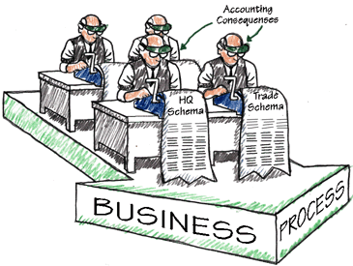
Note, that in contrast to Set of Books, Calendar is not directly part of an Accounting Scheme, as you may have multiple calendars per accounting schema. The calendar is reduced to transaction support functions (open/close periods, summary postings, allocation definition ease of entry).
In contrast to most applications, Streamix differentiates Transaction and the resulting accounting consequences with the following benefits:
- Transaction data is not replicated
- You can add or discontinue an accounting scheme anytime
- You can generate accounting information for historical transactions
- You can modify or replace any attribute (and optionally regenerate the accounting)
- Easy to extend and to maintain
- Error tolerant (you correct it and regenerate)
Transactions are performed immediately with high priority (e.g. inventory update, invoice paid); the accounting is performed asynchronously with lower priority and depending on system load.
It is possible for customers to extend accounting rules, if the predefined accounting rules are not sufficient (internally, accounting rules are defined using an accounting rule engine).

Multi-Organization and Service-Center
Multi-Organization features ensure that different organizational entities can share data or make sure that private data is not accessible by other entities. Sharing data is the prerequisite for centralized functionality, outsourcing or service centers.
Many applications have attempted to add this feature, often with inconsistent ‘Organization’ definitions in accounting and distribution. Also, the concept of sharing and private data is often implemented by replicating data with its overhead and synchronization issues.
Streamix was designed to maintain different organizations and supports three entity levels
- System
- Client
- Organization-Hierarchy
System level data is mostly infrastructure information, but can also include system-wide business partners, products, accounting schema, etc. The system level is equivalent to the database installation. Streamix provides tools to synchronize different systems.
Client level data defines information and accounting structure as well as common business partners, products, etc.
The Organization level is the transaction level (i.e. System and Client cannot perform transactions, you need at least one Organization). Organizations can also have their own data and information structure, not shared by other Organizations. Organizations can be structured in hierarchies with the children able to access their parent’s data.
Data on each level can only be entered or modified (if the role you are using has write privileges for that level). You can view and use data of ‘higher’ levels, but not change it. Example: With a System level role, you can access and change System data, but not access or view Client or Organization level data. With an Organization level role, you can use all System or Client defined data, but cannot modify any. A role may allow maintaining multiple levels (e.g. specific Client and specific Organization data).
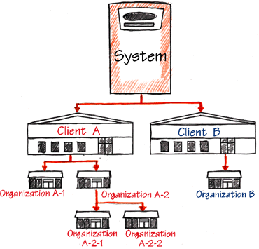
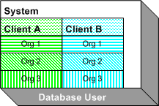
Certain entities like business partners or products require accounting information. Accounting information is maintained on the client and organization level, but not on system level. If you want to share a system level entity, you need to enter (or default) the accounting information. Without this, the entity is not visible for the organization. This allows an organization to be selective in what to ‘inherit’ and overcomes a major hurdle to sharing data. Many applications have the accounting information as part of the normal attributes of an entity, making it difficult to share or forcing the same information structure among the entities that want to share information.
Streamix also allows you to reorganize your Organization structure or merge entities.
Service Centers are virtual organizations performing transactions for other organizations. Examples are centralized purchasing or outsourced accounting services. Roles can be set up that allow central departments or external organizations to access the functional area, with access only to the required information. Service centers can access multiple organizations without changing roles, even if the organizations have different information and accounting structures.
Streamix automatically supports multiple Legal Entity accounting, ensuring that transactions crossing legal entity boundaries are accounted correctly. This can include calculation of cost charges (e.g. selling organization is a different legal entity than the product owning organization).

Accounting

The “Account”
We refer to Account as the fully qualified valid combination of information structure segments:
- In the Information Structure of your Accounting Schema you selected segments you want to report on. The mandatory elements are: Company and Natural Account, optional elements are for example, Business Partner, Product, Project, etc.
- If an element is mandatory, it must be specified for the combination to be fully qualified.

Elements with Account Information
The objective is to generate all accounting transaction entries. Consequently, all accounts are predefined. For example, if you sell a product, the revenue account defined with the product is used. This allows you to define just once what accounts should be used and not worry about accounting while entering transactions. To ease the data entry for accounts, all accounts have defaults defined at the Accounting Schema. The defaults for Products come from their Product Category - the defaults for Business Partners come from their Group.
Then the accounting rules determine based on the transaction context and rule set, what accounts (and amounts) to use:
Element | Account | Default
Business Partner - Customer | Receivables  Customer Prepayment | Business Partner Group
Business Partner - Vendor | Liability  Liability (Services)  Vendor Prepayment | Business Partner Group
Business Partner Group | Receivables  Customer Prepayment  Payment Discount Exp  Receivables Write-Off  Liability  Liability (Services)  Vendor Prepayment  Payment Discount Rev  Unrealized Currency Gain  Unrealized Currency Loss  Realized Currency Gain  Realized Currency Loss  Withholding  Not invoiced Receipts  Unearned Revenue  Not invoiced Receivables  Not invoiced Revenue | Accounting Schema
Business Partner - Employee | Expense  Prepayment | Accounting Schema
Product | Revenue  Product Inventory  Product Cost Difference  Expense  Cost of Goods Sold | Product Category
Product Category | Revenue  Product Inventory  Product Cost Difference  Expense  Cost of Goods Sold | Accounting Schema
Warehouse | Inventory (Asset)  Inventory Differences  Inventory Revaluation | Accounting Schema
Project | Project Asset  Work in Progress | Accounting Schema
Tax | Tax Due  Tax Liability  Tax Credit  Tax Receivables  Tax Expense | Accounting Schema
Bank | Cash In Transit  Bank Asset  Bank Expense  Interest Expense  Interest Revenue  Unallocated Cash  Unidentified Cash  Settlement Currency Gain  Settlement Currency Loss  Revaluation Gain  Revaluation Loss  Payment Selection | Accounting Schema
Cash Book | Cash Asset  Cash Transfer  Cash Difference  Cash Expense  Cash Receipt | Accounting Schema
Withholding | Withholding | Accounting Schema
Charge | Expense  Revenue | Accounting Schema
Company .. Company | Due To  Due From | GL Defaults
You can reset or overwrite the account settings from the default screen, Example: from the Account Schema Default screen, you can overwrite the accounts used in the Product Categories, from there you can overwrite the Product Account settings. This is useful, if you change your accounting structure, but overwrites individual settings.

Accounting Schema Accounts
In addition to default accounts, the following General Ledger accounts are defined for every accounting Schema:
Account | Description | Comment
Suspense Balancing | Source Currency differences in documents | used only when enabled - if not, the document is not posted
Suspense Error | Accounts are not valid | used only when enables - if not, the document is not posted
Currency Balancing | Accounting Currency (rounding) differences in documents after conversion | used only when enabled - if not, the biggest line amount is corrected
Retained Earning  Income Summary | Year End Processing

Accounting Rules
Accounting rules allow creation of “natural” accounting entries - in the way you see them in accounting textbooks. Compared with most applications, this reduces the number of accounting lines and makes the accounting easier to understand, check and audit.
Streamix can have different accounting rules. Advanced users can change the rules to reflect country or company specific procedures.

Account Masking
The actual account used in the transaction depends often on the context. There are several situations, that the Company segment is overwritten:
- Product Inventory - Company segment from warehouse, remainder from product
- Liability/Receivables - Company segment from transacting organization, remainder from business partner
As Streamix maintains the information on detail level, the available context information is filled in (e.g.. business partner, project, etc.).

Base Rules
Base Rules cannot be modified or overwritten and protect the integrity of the system. They basically ensure balanced accounting entries.
Rule | Description
rejectUnbalanced  createSuspenseBalancing | Reject, if the entry is not balanced and suspense balancing is not enabled. If suspense balancing is enabled, an additional source line is created
rejectError  createSuspenseError | Reject, if the account is invalid and suspense error is not enabled. If suspense error is enabled, the account in error is replaced
rejectUnconvertible | Reject, if the document currency cannot be converted to the accounting currency
rejectPeriodClosed | Reject, if the accounting date is in a closed period.
balanceCurrency | The accounting entry is balanced either via posting the difference to the Currency Balancing account or correcting the largest balance sheet account amount.
multiOrg | Transaction entries for multiple organizations: due to - due from

Tax Rules
Most tax entries are created by the transaction. Tax rules create correcting tax entries for Sales Tax and VAT systems. The main areas are prorating tax entries for payment discounts and write-offs as well as tax treatment of prepayments.

Costing Rules
Different Costing Methods post to different accounts using different amounts. For details see Streamix Costing.

Bill of Material

A Bill of Material (BOM) contains one or more Products, Services or BOMs. There is no limit how many elements a BOM can contain nor how many levels a BOM can have.
A BOM has to be “cycle-free”, which means that a BOM cannot refer to itself or parts (e.g. found in recipes in the chemical industry).

There are two types of BOMs

Stocked
On Product Tab, the attribute “Stocked” is selected Stocked BOMs are treated as normal products in terms of availability. To create then, you need to assemble (or disassemble) them via “Production”.
The available quantity represents what actually is stocked, not what could be produced.
If the price is 0.00, the price is dynamically calculated (i.e. sum of the individual parts). In this case the BOM and all its parts need to be in the price list selected.
Usually, only the BOM information is printed. For invoices, delivery-slips and pick-lists, you have the option to print the details - In the details, the quantity is listed.

Non-Stocked
Non Stocked BOMs are mainly for data entry convenience. When processing the order or invoice, the actual product lines are generated.
Available Quantity of non-stored BOMs is dynamically calculated on an item-to-item base and represents what could be available.
The price of a non-stocked BOM is always the summary price of its individual parts.

Sales Order Processing

This page gives an overview and examples of sales order processing.

Overview

Order Types
Streamix supports the following sales order situations:
- Standard Order - Create an order and reserve inventory; Ship products and generate invoice later. This is usually used when you ship products by availability. You can generate the invoice immediately or after the shipment.
- POS Order - In one step, create the order, generate the shipment and the invoice and receive the payment (Cash, Check, Credit Card, ACH transfers). This is usually used in ‘over the counter’ sales situations with anonymous customers.
- Credit Order - Create the order, generate the shipment and the invoice - and optionally receive the payment. This is usually used for known (on account) customers, with or without a credit line.
- Warehouse Order - Create the order and ship the product. Generate the invoice later. This is usually used when you want to create summary invoices. You can select the shipments manually or create the invoice based on invoicing rules (e.g. weekly, on the 1st and 15th of a month, etc.).
- Prepay Order - Create the order and a pro-forma invoice; Send the shipment and generate the final invoice after receipt of the money.
- Return Material Authorization (RMA) - Receive (previously shipped) item and create a Credit Memo.
You can convert Offers to orders, but also change from one order type to another.

Invoice Rules
Invoice Rules determine when an invoice is created. You can change the invoice rule to one of the following:
- Immediate - The invoice is generated immediately for the complete order
- After Delivery - An invoice is generated automatically after delivery for each shipment
- Customer Schedule after Delivery - An invoice is generated automatically based on the customer Invoice Schedule. The invoice could also be generated manually by selecting the shipments to invoice.

Delivery Rules
Delivery Rules determine, when a shipment is created. You can change the delivery rules to one of the following:
- Immediate - The Shipment is created immediately for the complete order; If you order more than currently available on stock a warning is issued. Alternatively, you could prevent an order to be entered for item not currently available (on hand quantity minus reservations).
- Availability - A shipment is created as soon as any line item can be shipped. This may create multiple partial shipments.
- Complete Line - A shipment is created when the complete line (i.e. the complete ordered quantity) can be shipped.
- Complete Order - The shipment is created when the complete order with all lines can be shipped.
- After Receipt - The Complete Order is created after receipt of the payment and when the complete order with all lines can be shipped.
Every order has a priority. The when generating shipments, the priority setting makes sure that high priority orders are shipped first and may cause that orders with lower priority are not shipped or only shipped partially.

Automatic Back Ordering
After entering an order, you complete or process it.
A processing reserve inventory, but does not create documents and is an optional intermediate step used when the order entry is not complete yet, but you want to reserve the inventory.
Completing the order reserves inventory (if not reserved yet) and generates the “push” documents. A “Standard Order” for example does not create documents, whereas a “Walk-in Order” creates the invoice and shipment directly.
After the order is entered, the system tries to generate the shipments and invoices to complete the order. You don’t have to explicitly back order items in this automatic process. You can setup the system, that you receive notifications, if an order cannot be shipped in a certain time period.
If you close an order, the remaining reservations are canceled with the effect that no item is back ordered for that order.

Examples
You can change the names of the different order types and create new order types. This uses the default names.

POS Order
You would use POS Orders in ‘over the counter’ situations, where the customer picks up the goods/services and pays for them immediately. In one transaction, you “ship” the product, invoice it and receive the payment.
- In the Sales Order Window, select “POS Order” as your Target Document Type.
- In this situation, you can use an “anonymous” Business Partner to record the transactions - or better create a new Business Partner on the fly to capture their details and address for follow up actions. Right-click on the business partner field and select “New Record”.
- Save the header and enter the lines. As you enter the lines, the total is displayed at the bottom of the window.
- Go back to the Order Header. You know now the total amount. You can change the default payment rule of Cash to other payment means line Credit Card, Check ... or even On Credit (e.g. if you accept that the customer pays later by cash, check, etc.).
- Press the “Complete” button. The Order is checked for completeness and as an indication becomes inactive (gray). At this point all documents (Shipment, Invoice) are created.
- You can print your POS Order Invoice now by pressing the Print button. If you press Print before completing the Order, an Order Acknowledgment is printed.

Credit Order
You would use Credit Orders in ‘over the counter’ situations, where the customer picks up the goods/services but pays for them later. In one transaction, you “ship” the product and invoice it.
- In the Sales Order Window, select “Credit Order” as your Target Document Type.
- Select a Business Partner and save the header and enter the lines. As you enter the lines, the total is displayed at the bottom of the window.
- Go back to the Order Header. You know now the total amount. You can change the default payment rule of On Account to change your (default) payment term.
- Press the “Complete” button. The Order is checked for completeness and as an indication becomes inactive (gray). At this point all documents (Shipment, Invoice) are created.
- You can print your Credit Order Invoice now by pressing the Print button. If you press Print before completing the Order, an Order Acknowledgment is printed.
If you receive the payment as Cash, you add the receipt as a new line in the Cash Journal window. If you receive the payment by Check, you create a new Payment in the Payment screen.

Warehouse Order
You would use Warehouse Order if your customer picks up the goods/services or you deliver them and create (summary) invoice later.
- In the Sales Order Window, select “Warehouse Order” as your Target Document Type.
- Select a Business Partner and save the header and enter the lines. As you enter the lines, the total is displayed at the bottom of the window.
- Go back to the Order Header and press the “Complete” button. The Order is checked for completeness and as an indication becomes inactive (gray). At this point the shipment documents is created. Please note that the status of “Complete” means that the Order Entry is complete and you can start creating Invoices. The report Open Orders lists orders not completely invoiced.
- You can print your Warehouse Order Delivery Note now by pressing the Print button. If you press Print before completing the Order, an Order Acknowledgment is printed.
If you want to create Summary Invoices (one invoice for several shipments/deliveries) you follow the following steps:
- In the Business Partner window on tab Customer, you
  - select the Invoice Rule “Customer Schedule after Delivery” and
  - select an Invoice Schedule (If an invoice schedule does not exist, zoom to the Invoice Schedule window and create it. In the Business Partner screen right-click on the Invoice Schedule field and refresh the selection)
- When you create a new Order for this customer, the Invoice Rule is automatically used and you have to change it in the Order, if you want to change it.
You create the invoice by either
- Starting the Generate Invoice process from the menu. This creates all invoices, which can be created based on the Invoice Rule.
- Starting the Generate Invoice (manual) form from the menu. Here you can select, which invoices you want to create.
If you receive the payment as Cash, you add the receipt as a new line in the Cash Journal window. If you receive the payment by Check, you create a new Payment in the Payment screen.

Standard Order
You would use the Standard Order, when you want to create the Shipments and Invoices in Batch at a later time.
- In the Sales Order Window, select “Standard Order” as your Target Document Type.
- Select a Business Partner and save the header and enter the lines. As you enter the lines, the total is displayed at the bottom of the window.
- Go back to the Order Header and press the “Complete” button. The Order is checked for completeness and as an indication becomes inactive (gray). After this point you can create the shipments and invoices. Please note that the status of “Complete” means that the Order Entry is complete and you can start creating Shipments and Invoices. The report Open Orders lists orders not completely invoiced or shipped.
- You can print your Standard Order Confirmation now by pressing the Print button.
You generate the Shipments by running the Generate Shipments from the menu. This generates the shipments based on the Delivery Rule (i.e. if the Delivery Rule is “Available”, no shipments are generated if the product is not on stock).
You create the invoice by either
- Starting the Generate Invoice process from the menu. This creates all invoices, which can be created based on the Invoice Rule.
- Starting the Generate Invoice (manual) form from the menu. Here you can select, which invoices you want to create.
Check the steps above to create summary invoices.
If you receive the payment as Cash, you add the receipt as a new line in the Cash Journal window. If you receive the payment by Check, you create a new Payment in the Payment screen.

Open Item Management

Streamix highly automates the open item management with Payment Rules.

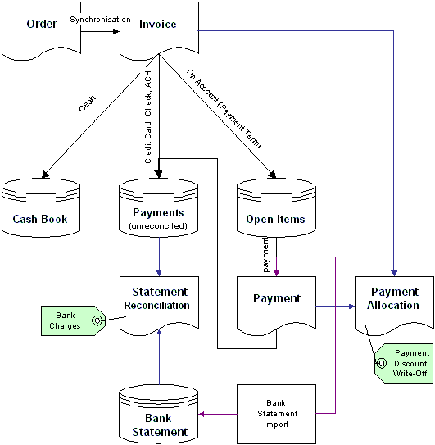

Invoice Payment Rules
Depending on the Payment Rule of your invoice, receipts are automatically created. The payment rule is listed in the button. You can also set and change the payment rule in the order and the generated invoice will be changed accordingly. The payment rule can also be changed after the invoice has been processed (example: an on account customer came in and paid an invoice with cash). You can select from the following payment rules:
- Cash
- On Account (Payment Term)
- Credit Card
- Check
- Transfer - ACH
- (planned: ATM)

Cash
If you select cash, an entry is automatically made in the default Cash Book for that day. You can change the cashbook and the day of receipt. The default cashbook is determined by the organization owning this transaction.

On Account (Payment Term)
For on account customers, select the payment term. The payment term defaults to the payment term in the Business Partner definition or if not specified there to your default payment term.

Credit Card
You can enter and process credit cards online. If you have more than one payment processor, the best payment processor is selected based on the calculated change for this payment. The invoice is marked as paid and the charge maintained in the system is an un-reconciled payment.

Check
You can enter checks by selecting a bank account. If enabled, you can process checks online (as electronic checks). The invoice is marked as paid and the check maintained in the system is an un-reconciled payment.

Transfer
You can use Automatic Clearing House facilities of your bank to direct debit your business partner’s bank account. The invoice is marked as paid and the transfer maintained in the system is an un-reconciled payment.

Payments
Payments (via Credit Card, Check, Transfer) are created when you enter your invoice or can be entered later. If a payment is for one invoice with the exact amount, there are no additional steps. If the payment is for multiple invoices, or if multiple payments pay for one invoice, or payment discount was taken, you need to confirm this by allocating the payments to invoices.

Allocation
Allocation links (multiple) payments to (multiple) invoices or credit memos and records payment discounts and receivable write-offs. You simply select the documents and enter/confirm the difference (discount or write-off).

Bank Statement
You can import your bank statement, or enter it manually, or create it from payments.

Reconciliation
Reconciliation links your payments to the bank statements and posts the differences. The main source of differences are bank charges, e.g. from the credit card processor.

Cash Journal

You record all petty cash transactions in your cashbook. Automatically, invoices paid by petty cash are entered in the cash journal. Through this, a cash journal is created for every organization and every day.
In your cash journal you also record:
- General expenses (account defined in the cashbook)
- General revenue (account defined in the cashbook)
- Petty Cash differences (account defined in the cashbook)
- Charges
- Invoices - customer or supplier
- Transfer to (negative) or from (positive) your bank account
Entries in the cashbook are entered with positive (receipt) or negative (expenses) numbers.
If you have balanced the cash journal, you process it. For adjustments, create a new cash journal with the correcting entries.

Charges
Charges are used in Streamix to allow the user quickly to select non-product related costs and revenues. Examples are freight charges, bank charges or interest. Charges are the link to natural accounts.
A charge can refer to either expense items or revenue items. The charge ‘Freight’ could be revenue, you charge your customers or shipping costs you were charged by your supplier. The system determines the type based on the context. A charge in a customer invoice is revenue; a charge in a supplier invoice is expense. A charge with a positive amount in the Cashbook is revenue - with a negative is a cost item.
The can define the tax of the charge. For invoicing, charges can be forced to be the same tax as the main line item. This is usually used in Value Added Tax systems.
You can predefine the charge amount, to speed up data entry. The default amount is not in a specific currency. The currency of the document determines the currency of the charge

Data Import

Streamix provides interfaces according to the OAGIS (Open Applications Group Integration Specification). The interfaces are implemented in XML or via Interface Tables. The Open Applications Group is a nonprofit consortium focusing on best practices and processes based on XML content for eBusiness and Application Integration. It is the largest publisher of XML based content for business software interoperability in the world. Open Applications Group, Inc. members have over 5 years of extensive experience in building this industry consensus based framework for business software application interoperability and have developed a repeatable process for quickly developing high quality business content and XML representations of that content. Members include SAP and Oracle.

Interfaces
The following interfaces are implemented:
OAGIS Chapter | OAGIS Name | Use | Table Name
7 | Sync Customer | Business Partner Info, Address, Contact | I_007_Sync_BPartner  I_007_Sync_Address  I_007_Sync_Contact
24 | Update Inventory Count | Physical Inventory | I_024_Update_InvCount
45 | Sync COA | Chart of Accounts | I_045_Sync_COA
46 | Sync ExchngRate | Currency Exchange Rates | I_046_Sync_ExchngRate
61 | Sync Item | Product definition and prices | I_061_Sync_Item
The data elements are defined in the OAGIS documents and also in the table definition. In situations where the “Sync Customer” interface is to complex, you can load addresses in a single record via I_Address.
We are also working on the synchronization of addresses and appointments with Microsoft Outlook.

Steps

Loading Data
As the first step, you need to load the interface tables. You can do that directly via SQL loader functionality. The other option is to define your import format.

In the Format Field, you associate the import element with the database column. You can invoke conversion routines to manipulate data. For example a routine could map data to your format and values.
The next step is to check the format and load the data:

Importing Data
The imported data can be viewed and if necessary corrected before the actual import process. The import process verifies the correctness of data.
Status | Description
OK ... | Record was imported with detail information
I_Ignored | Record ignored (e.g. not active)
IE_CurInvalid | Error: Currency invalid
IE_BPartnerInvalid | Error: Business Partner Value invalid
Product Import:
IE_NOItem | Error: Item field is empty (Product value)
IE_UOM_Invalid | Error: Invalid Unit of Measure
IE_ProdCategoryInvalid | Error: Product Category is invalid
IE_VendorNoNotUnique | Error: Product Number of Vendor not unique for that vendor
IE_ItemValueNotUnique | Error: Item/Product Value is not unique

Price Lists

Overview
Price lists determine what you can sell. If a product is not on a price list, you cannot put it on a sales order or customer invoice. As you can have multiple price lists, this allows you what to sell to whom.
Usually, you have one default price list. In the Business Partner screen, you can assign a specific price list to a business partner.
All price lists entries have three prices
- List Price (the official price)
- Standard Price (your price)
- Limit Price (your lowest price)
Price lists are organized in three levels
- The Price List (example: retail, wholesale, customer specific, ...)
  - Price List Version (valid from a specific date)
    - Price (the actual product or service price)

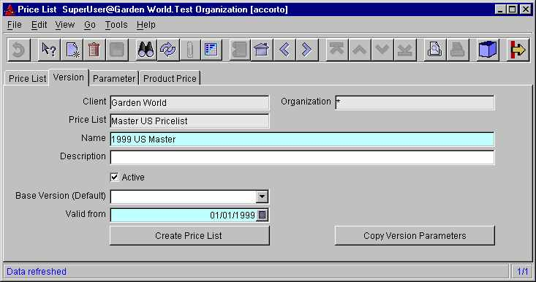

Price List Version
A price list can only have one version active at specific time. This date driven control allows you to create price lists for a future date, which become automatically active on the date you specified.

Creating Price Lists
You can always create or extend a price list manually by adding the product to the price list version. In most cases, you would create them automatically.

Parameters
You can create your price list from product vendor prices or from other price lists. To automate this, you create Price List Version Parameters. The Parameters are executed in the line sequence. This allows you to create a general parameter followed by more specific ones

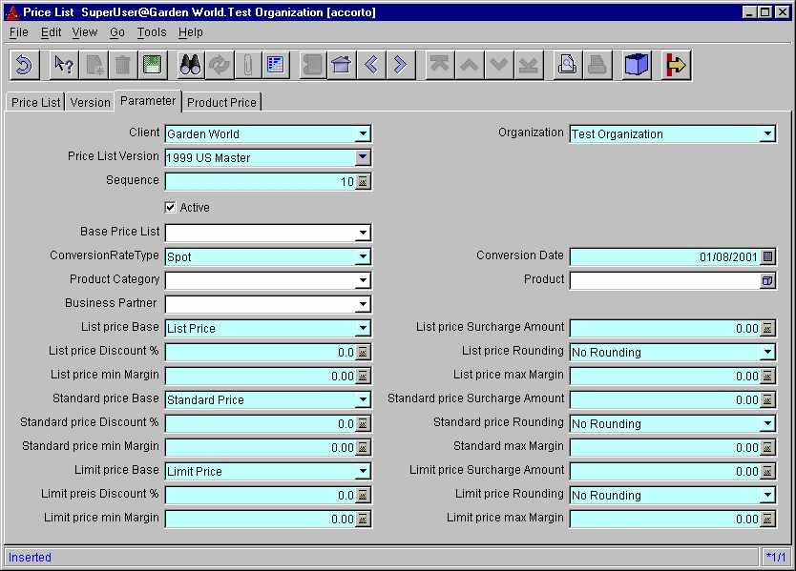

Example: In general you get 35% discount on items of vendor A, but only 20% for a specific product category. You would create two entries: one with 35% for vendor A, a second one with 20% for vendor A and the specific product category. The last entry overwrites the general 35%, so you don’t need to create an entry for all the product categories from this vendor.

Source Selection
The two sources are
- Product Vendor Prices (as defined/imported in Product “Vendor Detail” screen or in the Vendor tab of the Product screen.
- Other Price List Versions
If you leave the “Base Price List” field blank, the vendor price is used. If the source price has a different currency then the price list you are creating, you need to specify how the conversion should be calculated.
You can restrict the products to copy by specifying
- Business Partner (vendor)
- Product Category
- Product
Tip: For your own products and services (i.e. not the resell items), enter yourself as a vendor and enter the price in the Product Vendor screen. This allows adding your offering to price lists automatically.

Price Calculation
Each of the three prices (list, standard, limit) is calculated based on
- Price Base (either List, Standard, Limit) of the base price list
- Surcharge (amount added on the base price) - can be negative
- Discount in % (subtracted from base price plus surcharge)
- Minimum and maximum Margin (difference between limit price of the base price list and the calculated price before rounding) only if not zero
- Rounding
The calculation steps are:
- Copy and convert price from referenced price list
- result plus Surcharge Amount
- result minus Discount
- if resulting price is less than the original limit price plus min Margin, use this price (only if Margin is not zero)
- if resulting price is more than the original limit price plus max Margin, use this price (only if Margin us not zero)
- Round resulting price
The Formula is :
NewPrice = (Convert(BasePrice) + Surcharge) * (100-Discount) / 100;
if MinMargin <> 0 then NewPrice = Max (NewPrice, Convert(OrigLimitPrice) + MinMargin);
if MaxMargin <> 0 then NewPrice = Min (NewPrice, Convert(OrigLimitPrice) + MaxMargin);
Example (assuming same currency)
Original Prices: List=300, Standard=250, Limit=200;
New List Price: Base=List, Surcharge=0, Discount=0, Rounding=.10, Min Margin=0, Max Margin=0
=> 300
New Standard Price: Base=List, Surcharge=10, Discount=20, Rounding=.10, Min Margin=10, Max Margin=30
=> 230 == (300+10)*0.8=248, Max(248,200+10)=248, Min(248,200+30)=230
New Limit Price: Base=Limit, Surcharge=1, Discount=-11, Rounding=1.00, Min Margin=10, Max Margin=0
=> 223 == (200+1)*1.11=223.11, Max(223.11,200+10)=223.11 == 223.00

Base Price List
The Base Price List entry in the Version tab is the default for the parameters. If you select a value, you indicate that you want to the prices from another price list rather than the vendor prices.
If you have multiple vendors for a product, the price information from vendor prices (in window “Product” tab “Purchasing” or window “Vendor Details”) of the Current Vendor is used. Prior to creating the price list, is checked that there is only one current vendor per product; if not, an error message is printed. Vendor prices are mapped as follows: List and Standard refers to the vendor list price; the Limit refers to the vendor PO price.
You can also change an existing price list (e.g. add 5%). You would then select the same price list as the target one in your Base Price List.

Purchase Price List
The major use for price lists is to determine what to sell to your customers at what price. You can also use price lists for purchase price control. For this feature, you need to use standard costing.
Example: Your discount is 30% on list and you’ll get another 10% on list as a credit every quarter. So, your total discount is 40%, but the invoice amount lists 30%. You would create a purchase price list with standard price = 30% of list and limit price = 40% of list. Invoices received will be checked against the 30% discounted price, but the 10% are accounted as a purchase price difference. If you receive the credit, you need to post it to the same product or product category. You can check the amount outstanding, it should be zero after you receive the credit.

Example Steps
- Import or enter the vendor prices (in window “Product” tab “Purchasing” or window “Vendor Details”)
- Create a base price list (this could be your purchase price list)
  - Create a version WITHOUT a base price list
  - Enter the parameters WITHOUT a base price list
  - Create/generate the prices
- Create a sales price list
  - Create a version referring to the price list you created earlier (the base price list on the version is only a default for the parameters)
  - Enter (or copy) the parameters and select the price list you want to copy the prices from
  - Create/generate the prices

Application Integration

Functional Integration
Streamix fully integrates Enterprise Resource Functionality with Customer Relationship Functionality and Analytical Processing. This tight integration ensures that the different functional areas have all the information required for business decision-making. There is no need to derive information as everything is based on the source transaction.
Many applications do not provide full functional integration. In Streamix entering or viewing Project information in transactions does not require additional steps. When exceptions occur, like vendors owing money or customers requiring refunds, Streamix treats these without additional overhead.

Interfaces

Business Views
If the internal reporting facilities are not sufficient, third party SQL based tools can be used. Streamix provides business views, which resolve all foreign key references and are therefore ‘ready to use’. There is no need for data model knowledge or developing and maintaining catalogs for these third party tools. Streamix also provides the required Security framework automatically.

Data Export
Streamix exports all data in reports to the following data formats:
- Excel
- HTML
- XML
- Text
- PDF
- PS
- Word
- Business OLAP Cubes
Streamix allows exporting of OLAP data to Excel Pivot tables and selected OLAP tools for further analysis.

Data Import
Streamix imports data from XML, fixed records, etc. There are predefined formats, but you can also define your own record formats.

Scanner
Streamix provides a scanner interface for order entry and inventory transactions like receipts, shipments, move and physical inventory counts.

J2EE Connectors
Java Enterprise Edition Connectors will be available for integrating EIS applications.

eCommerce

XML: OAGIS and OFX
Streamix provides interfaces according to the OAGIS (Open Applications Group Integration Specification). The interfaces are implemented in XML or via Interface Tables.
The Open Applications Group is a nonprofit consortium focusing on best practices and processes based on XML content for eBusiness and Application Integration. It is the largest publisher of XML based content for business software interoperability in the world. Open Applications Group, Inc. members have over 5 years of extensive experience in building this industry consensus based framework for business software application interoperability and have developed a repeatable process for quickly developing high quality business content and XML representations of that content. Members include SAP and Oracle.
Streamix supports OFX (Open Financial Exchange) transactions. Open Financial Exchange is a unified specification for the electronic exchange of financial data between financial institutions, business and consumers via the Internet. Created by CheckFree, Intuit and Microsoft in early 1997, Open Financial Exchange supports a wide range of financial activities including consumer and small business banking, consumer and small business bill payment and bill presentment.

EDI
To support ‘traditional’ EDI, Streamix supports selected X12 transactions including Email based variants. Supported transactions include:
- Purchase Order
- Shipment
- Invoice
- Product Availability

Extensions
In addition to the standard customizations, Streamix provides the ability to extend the application. In contrast to other applications, client extensions are also possible in a hosted environment and are maintained during upgrades. See also Customization & Extensions and Building from Source

Information Structure
If the information structure is not sufficient, clients can add fields to any record with its presentation and validation rules. Data entry can be made mandatory, if certain conditions apply. The entry validation can be based on lists, tables or functions like callouts.

Scripting
Streamix Scripting allows user to extend the functionality using Java syntax. It is also used for conversion.

Call-out
Functional extensions are implemented via ‘callout’ technology. Clients can provide additional functionality in Java or even native C functionality, e.g. for additional validation or data feeds. Callouts can be invoked before or after data entry in any field. Streamix ensures that callouts cannot crash or corrupt the system.

Rules
The advanced user can extend and in certain areas modify the rule base. Rules are organized in packets making sure that transaction integrity is maintained. Rule extensions could be used for generating statistical entries or special reporting needs.
Currently, rules are used for creating accounting transactions and for pricing.

Application Features

Workflow and Wizard
Streamix provides a built-in workflow system. A workflow is a guided series of steps where potentially more than one user is involved. A step can be starting a process, running a report or entering information in a window.
Approval hierarchies do not require an explicit workflow, but become involved automatically, if the current user’s approval limits are not sufficient. The same applies, if tasks, in a workflow, cannot be performed due to functional or data security restrictions of the current user.
Workflows could be month-end tasks, etc. The system provides predefined workflows for many non-routine tasks.
Workflows maintain a context, automatically querying the required data or providing defaults for new records to be entered.
Whereas Workflow connects steps, Wizards provide guidance within the fields of windows.

Attachments and Images
Streamix allows attachments for every record in the system. The attachments can be simple notes, external files (e.g. Excel) or images. If a record has an attachment, is displayed in the toolbar.

Alerts
A user can define business exception situations to receive proactive notifications. The notification can be a simple note or running a process or report.
Examples are a list of customers with a certain percentage over credit limit, long outstanding open items, new customer, not moving inventory, etc.
In the background Streamix automatically provides proactive reporting of issues resulting from system consistency monitoring and failure detection

Scheduling
Streamix provide an integrated scheduler for processes and reports, and the result is sent via Email to a particular user or a mailing list. This allows easy Report Distribution.

Email integration
Standard (multilingual) Emails are generated by the system for notifications like approval requirements or Alerts.
Email can also be used to create customer letters or automatic confirmations.
If an error occurs, the user can send the error message with system generated supporting information to an internal support person or Streamix Support directly.

Help
Streamix provides an integrated, customizable multilevel help system. Every task, report and window and tab has overview information, every field has a ‘tool-tip’ hint and a help text.
If the help is not sufficient, the user can ‘zoom’ from the help window to Streamix online Internet help system for up-to-date information, tips and Q&A sections.

Product Advantages

Fast Implementation without final decisions
Implementing Streamix is a matter of hours, not weeks or months. As our competition, we use templates to tailor the software to your needs. But, in contrast to our competition, Streamix does not restrict functionality - no “cookie cutter” predefined system!
Streamix does not require any irreversible implementation time decision (or make it for you). You can change everything later, including chart of account, business calendar or even the accounting currency or accounting principles. See on structural changes midstream. In Streamix, these changes do not require any specific technical skills or intervention.
This does allow you to go into production fast. You can adapt your system to the changing business environments whenever needed.

‘Reach’ HTML and ‘Rich’ Windows User Interface
Streamix offers two parallel user interfaces: A browser based DHTML web based interface designed to reach your application from anywhere on the Internet and a high performance Windows Application with a rich user interface - allowing high speed (mouse-less) data entry. Both user interfaces are generated using the same rules with the same look and feel, while exploiting the advantages of their platform.
None of our competitors were designed for and fully support both user interfaces. In environments, where fast reaction is key and where you need to access multiple information sources - like in order entry - the “traditional” Windows based user interface cannot be replaced (yet) by an HTML based application. The client Application is self-installing and automatically upgrading, for easy operation.
For remote offices, at client sites or via wireless devices, you want to access the application fast. Streamix provides a light DHTML interface with low server requirements. The Client Application is used in production with just 128-k bandwidth - the browser interface provides reasonable response with just 56k.

Smart User Interface (Personalization)
Complex applications have a long learning curve as you need to know what the different options mean. Streamix uses a different approach:
Streamix uses context sensitive Personalization. You only see what you need! For example, if you don’t use foreign currencies, you don’t see it - but it is there in the situations where you need to transact in a foreign currency. Another example is the different processes and fields required for different payment options. You only see the information required in that specific situation and context. Our marketing people call this “reserve functionality”.
All information entered is immediately validated; data entry tips are provided. The consistent user interface is generated based on rules, resulting in an extraordinary stable application. Without hand coding, Streamix provides cross-field validation and supports field dependencies (e.g. the address is dependent on the customer selected).
You can rearrange the entry forms, hide fields, change colors and fonts as well as change labels and add customer specific help and hints. Advanced users can add fields and create validation rules.
The Streamix dynamic user interface makes the application easy to use and decreases the learning curve. The functionality is available in both, the HTML interface and the Windows Application.

Rule Based “Safe-Fail” Architecture
Streamix is based on extensible business rules. Not just the user interface is rule based, but also processes and procedures. The system provides an extensive set of rules and advanced users can refine and extend their business rules. The system always ensures its integrity, and a user cannot accidentally overwrite these rules.
In contrast to its competitors, Streamix was not designed assuming that everything works perfect and is fail-safe. Humans make mistakes, systems fail and there might even be the odd program bug.
Streamix allows the application to fail safely, always maintaining it’s integrity. Failed transactions can be resubmitted or in the case of a process error (e.g. wrong rule) transactions can be reprocessed, correcting the previously unnoticed error.

Truly Integrated Application
Streamix “Front Office” functionality - the customer relationship management - is fully integrated with the “Back Office” functionality - the traditional ERP. No interfaces, processes or time delays.
If you enable optional functionality like Project Management or Marketing Management functionality, the required details are captured directly at the source, providing you with the details required for exhaustive analysis .
The integrated OLAP Analysis functionality allows you to view your information in a slice and dice fashion.

Architecture Overview

Introduction

Streamix is developed using java language and J2EE architecture. Such an architecture guaranteed that Streamix perform on any platform and can easily scale up with almost no changes in the software (simply by adding more server to the cluster). Plus Java is one of the most secure languages in the industry. Even though Streamix can run on any J2EE Application server, it is targeted for Open source application servers such as Jboss. At present time Streamix runs only on Oracle database, however we are working to port the application to other databases including open source databases such as SAPDB or Mysql.

Server Architecture

The Streamix Server is based on JBoss and Java Management Extensions (JMX). All server services are implemented as Dynamic Managed Beans (MBean).
- JBoss Server (JMX compliant MBean Server)
- Streamix Server Services (JMX compliant Dynamic MBeans)
  - Accounting Server

  - Request Server
  - Utility Server
- Web Server & Servlet Container (JBoss/Jetty)
- EJB Container (JBoss)
This architecture allows to
- Manage the MBeans (start/stop/..) and inquire their status locally and remotely
- Ability to integrate with an SNMP (Simple Network Management Protocol) manager or CIM/WBEM manager
- Add your extensions and other J2EE applications

Application Architecture

Smart User Interface
The actual Windows Application User Interface and actual HTML screens are generated -at runtime - based on rules in the Application Dictionary. The result is a consistent User Interface, allowing users to navigate quickly in unfamiliar application areas. This method of generating a user interface allows fast development and the resulting system is much more stable than comparable applications.
The “rich” Windows Application UI utilizes the computing power of today’s PCs and is preferable in situations where fast reaction and navigation is important. The “reach” HTML User Interface allows using the application where you find an Internet browser.
The Data Dictionary knows about structure and dependencies. This allows the user with the right access to zoom from any Pick-List to the window where the data is maintained in order to update or enter new information. Users can enter a new customer or update existing customer information while entering an order without leaving the original window.
The Data Dictionary allows the user to quickly access information. If you need more entity information than a company’s name, you can invoke the Info functionality. For example, the Customer Info includes address and credit line information; the Product Info includes prices, margin and availability. Info is used if the user needs more information to make a choice. The selection can be sorted and restricted. Where appropriate, you can select multiple records.
You can Query records. Query reduces the number of records in a window by allowing the user to enter criteria in an enhanced ‘query by example’ style.
The user can customize Window layout and can tailor screens for a specific situation and client.

Application Dictionary
The majority of applications have to design, code and test every screen. Streamix uses the more advanced concept of a central active data dictionary, also called information repository.
Streamix data dictionary is at the meta-data layer, and knows how to access data and how data is related. The data dictionary contains definitions of a data entity (type, validation, etc.), how it is displayed (label on screens and reports, help, display sequence and position relative to other fields), and the display rules. Security and access rules are also maintained here. The data dictionary is ‘active’, meaning it is used at runtime and context sensitive. For example: it ‘knows’ that an over-the-counter sale does not have a payment term and does not display it. However if you change the transaction type to a standard order, a payment term becomes a mandatory part of the transaction.
The Data Dictionary is user-extensible and can include user specified rules and information.

Sustainable Architecture
Businesses applications change over time. They need to utilize new technology and always need to provide additional and smarter functionality. Packaged applications must also support additional functionality, although it is often not suitable for integration in the core functionality (e.g., customizations and certain extensions).
Even though it is known that requirements for packaged applications are constantly changing over time, very few applications are designed to sustain change and additions.
Business applications can have a long life expectancy and tend to provide more functionality over time due to enhancements, so it is important to provide a framework to manage this proliferation of complexity. If applications are not designed to sustain increasing complexity they will become unstable.
Streamix uses the following design principles in order to create a sustainable architecture:
- Smalltalk’s MVC architecture (decoupling of Model-View-Controller)
- Asynchronous decoupling of processes via messages
- Explicit Rule Engine for complex logic
- Safe-fail transactions and recovery
Streamix has Object Architecture (compared with Object-Oriented, Object-Like or traditional Architectures). Every Object is as independent as possible from other Objects - including transactional decoupling.
Early versions of the Streamix architecture were designed in the mid ‘80 using Smalltalk, one of the first truly object-oriented languages and environments. Other early roots of the architecture are based on the ‘Next Generation’ project of ADV/Orga, which was very similar to SAP’s original R/3 project, unlike today’s R/2 port.

Safe-fail
Usually applications are designed to be fail-safe: it is assumed that everything works and all data is entered correctly and is consistent. In the case of failure, experts have to search for the cause and check for damages. The user usually notices the problem. The reality is that applications sometimes fail.
In contrast Streamix is designed to be safe-fail. Every transaction can be repeated and regenerated. Most failures are identified by the system and the user can attempt to fix the problem. If recovery is not possible, the error is isolated and the rest of the system continues to work. Transaction de-coupling design is the basis for this ability.
An example: The transaction substructure of the transaction ‘cash sale of a product over the counter’ is:
- Material Transaction (adjust inventory)
  - Generate Material Accounting (for each Accounting Schema)
  - Post
- Invoice Transaction (calculate tax & create invoice)
  - Generate Invoice Accounting (for each Accounting Schema)
  - Post
- Receipt Transaction (create receipt for invoice)
  - Generate Receipt Accounting (for each Accounting Schema)
  - Post
To have ten or more transactions rather than one or two may seem to look like overkill, but it is actually faster and much more reliable than the standard approach:
When committing, only two sub-transactions are performed, the material and invoice transaction. This ensures a fast return, so that the user can continue with entering the next transaction. The remaining sub-transactions are scheduled, optionally batched and are executed asynchronously in parallel. This allows deploying load-balancing rules to ensure fast online response.
Each transaction only performs one task. This is easier to stabilize; the impact of failure is isolated and easy to identify.
The communication between the individual transactions is message driven, allowing asynchronous batching of transactions.
Additional functionality is much easier to implement. The cost of adding new functionality in Streamix is much less as in other Applications.
The user can continue working with little restriction, if the main transaction (e.g. inventory adjustment) is successful. The remaining transactions can be generated, after problem is fixed.
The system checks regularly if a transaction is complete. If a transaction is not complete and consistent due to system failure, the administrator and user are informed.
As applications become more complex with ever growing combinations, potential error causes grow exponentially. Streamix provides an extensive validation framework and in case that it fails isolates the problem ensuring high availability of the core functions.

Security
Streamix supports function and data security. Function security is based on User Roles and controls access to Windows, Reports and Processes.
Data security for Client and Organization information is maintained at database level through security context. This is an additional level of security after the normal database user login. This allows the use of third party SQL based tools to access the database. Before accessing any data the user must login via a stored procedure with application username, password, role and optionally language. This provides the same data access rules for third party tools as exist within the application.
Most applications have no security layer beyond the database user login and have difficulties restricting access though SQL based third party tools.
Passwords on Clients are stored in encrypted form.

Customization
In addition to customizing Smart User Interfaces, Customizing Reports and Extensions, Streamix provides additional customization capabilities:
Preferences allow default and pre-selected choices.
- Login preferences - Organization, Transaction Date and Printer.
- User defined preferences, like specific transaction types.
The Menu Bar allows the user to save any entry in the menu (Window, Process, Report) as a shortcut.
Terminology can be changed. Examples are: if you don’t have ‘Products’, but ‘Items’ if ‘Organization’ is called ‘Branch’, etc.
Help Text can be modified and extended to provide hints and help texts.
Customizations are definable on different levels.
- System or implementation wide
- Window, where appropriate (e.g., for preferences)
- Client
- Organization
- Specific User
More specific levels overwrite the settings of more general levels.
See also: integrating, extending and translating Streamix.

Smart Reporting
For most applications, Reporting is a separate or add-on entity. Streamix reporting is based on the data dictionary. As the report viewer has access to the definitions, this allows drill-down to any entity referenced and drill-across to entities where the reported entity is used. The links are automatically generated, while ensuring adherence to security and access definitions.
Business Views are designed for end users and allow accessing information using a standard SQL based tool without the need to create SQL table joins. The majority of Business Views are generated based on the Application Dictionary.
All reporting output can be viewed on screen before sending it to a printer or generating files in many different formats (e.g. Excel, HTML, XML, Word and PDF).
All reporting output allows drill-down to any entity referenced and drill-across to entities, where the reported entity is used.

Drill-down
When you drill-down, a new report is generated based on the entity selected. In an order report, you can drill-down to get a customer report by double clicking on a customer name.
Additionally drill-down is available by origin. Examples are reports where the number is an addition of numbers, or drill-down from a summarized monthly amount to the original transactions.
Following the Web-UI, you can drill-down to any blue underlined entity.

Drill-across
Drill-across allows the user create a new report where a specific entity is used. For example, in a Product report you select a specific line (product); then you can drill-across to an Order-Line or Invoice-Line Report to display only the lines, where this product is referenced.

Reporting types
Streamix has three built-in types of reporting facilities
- Lists
- Reports
- OLAP Viewer
Lists are based on Window information. You can generate a report for every window in the system.
Reports are often based on summarized information and are based on Report Views.
The OLAP Viewer allows viewing different dimension combinations in a table or as a graph.

Customizing Reports
Streamix differentiates the ‘view’ from the ‘model’. With the exception of Report Views, the model is usually given. If you provide a SQL Select statement a Report View can be created. In contrast to other applications, the user doesn’t need to resolve foreign key references (which requires the knowledge of the data model) or worry about data security, as Streamix resolves these issues for the user. This allows the writing of ‘simple’ statements.
Few people agree on how each report should look. Streamix allows the user to define at the System, Client, Organization or User level:
- Report columns
- Column order
- Report sorting
- Column heading
- Sums (for numeric columns)
- Grouping
- Pie Chart
- Bar/Line Chart
The language of the report is based on the user’s language. Each user can have a different language. The structure of the report is copied from lower (System, Client, Organization) levels.
Data selection is via Report Parameters when initiating the report, or via Query, allowing the user to enter criteria in an enhanced ‘query by example’ style.

Deployment Options

Streamix has the following main components:
- Client
  - Java Application
  - Java Applet
  - HTML based
- Servlet Server for HTML based Application
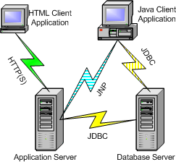
- Application Server
- Database Server
All application components can be deployed on all Java enabled platforms: Windows (NT, 2000), UNIX, Linux, Mac, etc.
A variety of configurations are supported. Where communication bandwidth allows, the Java Application Client can be deployed. A communication bandwidth of 128 kbps is sufficient for the Windows Application.
For the HTML Client, a Java Servlet and JSP (Java Server Pages) Server is required. In addition to the standard HTTP Internet communication, the SSL secure protocol is used.
The JBoss based Application Server could be deployed as a stand-alone tier or on the database server. Java Management Extensions (JMX) is used for Server Management.
The Database Server hosts data and application logic and is accessed by the standard JDBC (Java Database Communication) protocol. Functionality at the database level is implemented in PL/SQL.

Technology Stack
Streamix is a 100% pure Java solution based on Oracle database technology. We are working on database independence.
The client application component is written entirely in Java designed to utilize the capacity of today’s PCs. The Java Application or Java Applet client is the preferred choice for high data volume as it provides a high performance Windows based user interface. It communicates, via thin JDBC, with the database and via RMI with the application server. The client accesses the servers via the Internet or Intranet.
As an alternative, a HTML client could be used to extend, where the installation or download of the application is not appropriate (i.e. self-service functionality for vendors, customers, employees). This part is implemented through Java Servlet and Java Server Pages, to be hosted in Servlet Servers.
The JMX based application server component is implemented in Java based on J2EE technology using the JBoss server infrastructure. Some application functionality is implemented as PL/SQL.

Development Methodology
Sianix presents a new framework called Deliverables in Rollover Phases Matrix (DRPM) methodology for developing and customizing a service-oriented application, such as Streamix. Using a combination of Rational Unified Process, Extreme Programming and Feature Driven Development methodologist. We then use DPRAM to offer a timetable for National HealthCare Portal Project (NHCP)

Overview

One of the most known software development processes in the market is called Rational Unified Process or RUP. It is presented by IBM rational and provides several out-of-the box disciplined approaches and roadmaps of how to initiate a project by mitigating the risk to how to deliver the final product.
RUP emphasizes the adoption of certain best practices of modern software development, as a way to reduce the risk inherent in developing new software.
These best practices are:

- Develop iteratively
- Manage requirements
- Use component-based architectures
- Model visually
- Continuously verify quality
- Control change

These best practices are woven into the Rational Unified Process definitions of:

- Roles – sets of activities performed and artifacts owned.
- Disciplines – focus areas of software engineering effort such as Requirements, Analysis and Design, Implementation, and Test.
- Activities – definitions of the way artifacts are produced and evaluated.
- Artifacts – the work products used, produced or modified in the performance of activities

RUP is an iterative process that identifies four phases of any software development project. Those phases are:

- Inception
- Elaboration
- Construction
- Transition

Each phase contains one or more iterations where you produce an executable (deliverable)

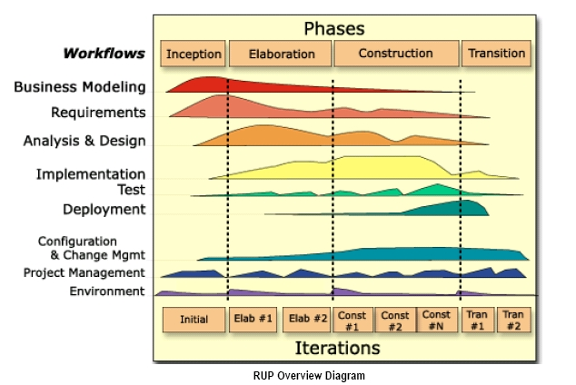

Even though RUP has been very successful handling large size projects, there have been some pitfalls associated with it on applying it for midsize projects. One of them is it’s emphasize over the risk mitigation, requirement and design documents. There have been many projects that spent most of their budgets on developing these documents and never had a chance to implement them.
As a response another development process developed in 1996 that emphasized more on testing, communication and development than on the documentations It is called eXtrme Programming or in short XP. XP consists of 12 practices including

- The planning game. Determine the features in the next release through a combination of prioritized stories and technical estimates.
- Small releases. Release the software often to the customer with small incremental versions.
- Metaphor. The metaphor is a simple shared story or description of how the system works.
- Simple design. Keep the design simple by keeping the code simple. Continually look for complexity in the code and remove it at once.
- Testing. The customer writes tests to test the stories. Programmers write tests to test anything that can break in the code. You write tests before you write code.
- Refactoring. This is a simplifying technique to remove duplication and complexity from code.
- Pair programming. Teams of two programmers at a single computer develop all of the code. One writes the code, or drives, while the other reviews the code for correctness and understandability at the same time.
- Collective ownership. Everyone owns all of the code. This means everyone has the ability to change any code at any time.
- Continuous integration. Build and integrate the system several times a day whenever any implementation task is completed.
- Forty-hour week. Programmers cannot work at peak efficiency if they are tired. Overtime is never allowed for two consecutive weeks.
- On-site customer. A real customer works in the development environment full-time to help define the system, write tests, and answer questions.
- Coding standards. The programmers adopt a consistent coding standard.

To support four values in the lifetime of the project and those are:

- Communication: communication between the customer and development team members by having an on-site customer while development progresses.
- Simplicity: by continually refactoring code and producing a minimal set of non-code artifacts.
- Feedback: through many short releases and continual unit testing
- Courage: doing the right thing, even when it is not the most popular thing to do.

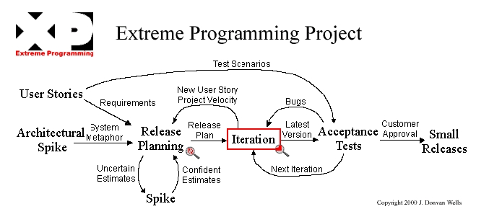

There has been many discussion of the pro, con and applicability of each process and even recently IBM released a new tool called eXtended Development Environment XDE to customize RUP based on each project and integrate part of the XP development process into that.

We combine these two main development process and integrate it with a third development process called Feature Driven Development or FDD where it breaks down a projects into many small releases that each add more features (or use cases) to the project. The result has been a new methodology called Deliverables in Rollover Phases Matrix methodology or DRPM
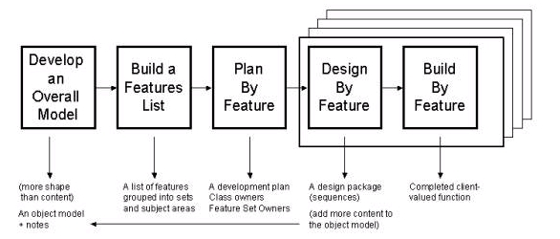

Deliverables in Rollover Phases Matrix methodology
DRPM divides the project into a matrix. A matrix consists of different phases where each phases consists of different deliverables. Contrary to RUP where each phase depends on the previous phase and works iteratively, Phases in DRPM don’t depend on each other rather are groups of functionality that can be developed more or less independently. On the other hand deliverables in each phase are depends on each other and released iteratively.

DRPM divides the project into 8-month long phases. Each phase is more or less independent of other phases. The reason that DRPM chooses this architecture is that there are roles that are being used only partly in one phase and can roll over to the other phases. For example a business analyst who is specialized on gathering the requirements from customer can do its job on the fist month of the project and even though can continue as a part time base on that phase can leverage its skill on the next phase. The same is for DBA or even project manager where is not occupied totally after the first month of the phase and can handle managing the next phase. Therefore in DRPM you may see 2 to 3 phases work in parallel.

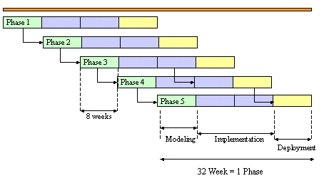

In this methodology emphasize is on role reusability to pass the experience of one phase to the other with minimum overhead to prevent under or over utilization of each role.

DRPM identifies 10 different roles in each project. Those are:

- Project Manager
- Business Analyst
- Graphics Designer
- Technical Architect
- Technical Team Lead
- Technical Writer
- Software Developer
- Application Tester
- System Admin
- Database Admin

Not all roles stay in the whole life of the project for example you may need system admin at the start or end of the project or technical writer in the middle of the project. Plus not all roles are fully occupied in the project for example Architect are very busy at the start of a phase but as that phase settles down and stabilized its architecture it can work on another phase of the project Also there are some roles that may not be necessary for some phases for example we may copy the system of one phase to the other one and therefore there won’t be any need for a system admin. Also one person may play couple of role in one project. For example a developer can also be an application tester. In a way all of these guidelines are based on the best practices and should be customized for each phase of the project. (For example we may have 6 or more developers work at the same time on one phase)

The following diagram shows utilization of each role in a project phase lifecycle

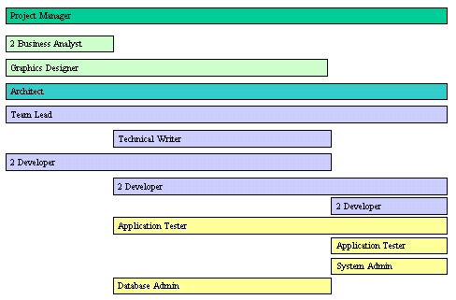

Based on the above utilization matrix we can derive the following estimate for each role in one phase: For a 24 weeks phase we have:

Project Manager | 600
Technical Architect | 600
Business Analyst | 480
Graphics Designer | 720
Technical Team Lead | 960
Technical Writer | 480
Software Developer | 3360
Application Tester | 960
System Admin | 240
Database Admin | 480
Total | 8880

As you can see DRPM divides the roles into three main teams:

- Business Team
- Technical Team
- Admin / Testing Team

The idea is that each team has periodic meetings and its member works closely together. For example, it is recommended that all three, project manager, business analyst and graphics designer participate in the meeting with clients to go over requirements. Plus it helps to rollover a team from one phase to the other rather than each person. It is more or less clear that utilization of each team varies in the life cycle of a phase. At start it is the business team that does most of the job then Development team and at end Admin/ Testing team and that is why we propose the color pattern in the Rollover Phase figure.

So far we follow RUP pattern where we concentrate on the requirement gathering, design and architecture (Inception & Elaboration) at the start, Implementation and development in middle (Construction) and testing and deployment at end (Transition). The difference is that the phases are done in parallel and not consecutive (RUP iterations). On the other hand we adopt iteration mechanism of XP & FDD where project releases small deliverables in short intervals (every four weeks) it is in such a short interval that you cannot go though all four steps required by RUP. Rather because the difference between each deliverables is minor in terms of adding more use cases and features (adopted by FDD) you don’t need any more design analysis or risk mitigation. In a way as the first deliverable of each phase are done by business team, developer team has enough time to work on proof of concepts and clear out any design flaw or architectural risks before their first deliverables.

The following diagram shows the schematic plan for deliverables in each phase:

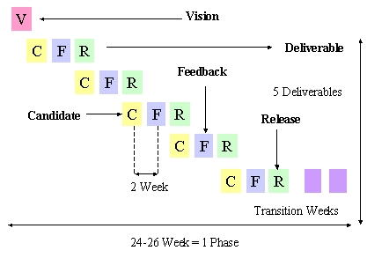

In this model the business team delivers the vision document (a high-level description of the application) on the first week of the phase (as the first artifact of the project). It then follows with 5 different deliverables with a 4 weeks interval one after each other. DRPM propose 3 steps for each deliverable:

- Candidate
- Feedback
- Release

At the Candidate step the team delivers a candidate solution to be inspected by the customer. Customer has one week to give its feedback on the solution and team has one week to implement customer feedback and deliver its final release.

There is couple of important issues that need to be considered in this process.

- To prevent the lengthy development process DRPM limits the deliverable process to two iterations. It means developer should work on the candidate to be a very close solution to the final release such that with another minor modification they can deliver the final product. At the same time Client should takes into consideration the one-week time frame to implement the necessary modification and limit the requested changes on the feedback. If the candidate is not close enough to the final release, the whole project plan should be justified to add the changes as a separate deliverable.
- The first major deliverable of each project is Architecture / Risk document (Define, validate, and baseline the architecture and any risk associated with it) which will be a month after the start of a project. That gives enough time to address all issues and risks in the project, to stabilize the architecture and follows the Inception and elaboration stage of the RUP methodology. On the other hand the developer team can setup their development environment, getting familiar with the architecture, requirements and even perform series of proof of concepts to perform the risk mitigation process proposed by RUP. In short the first month developer are busy to warm up and get ready to delivers their monthly releases.
- Even though DRPM recommends Continuous Integration developed and implemented by thoughtworks (using Cruise Control open source framework), because the development team is under pressure to release the monthly deliverables (while fixing the problems of the candidate deliverables) they may not have enough time to integrate all these deliverables continuously. Therefore we allocate 4 weeks and call it Transition Weeks where they have time to put everything together, clear out any remaining bugs, issues and garnish the final product for the final release.
- DRPM is based on a very tight schedule. It is not easy to deliver a release every four weeks. It requires complete coordination and coherence between Client and Development team. Client’s feedbacks should come on time and many decisions should be taken on site. Therefore it is important that Client identifies a point of contact that participate an almost all meetings, preferably be on site with developers and have the authority to make decisions on behalf of Customer. Otherwise the project falls into a lengthy bureaucratic process that takes weeks for any changes to be approved and cannot meet its deliverable deadlines.
- One of the deliverables at the end of each phase is a document called Software Architecture Document (SAD). SAD is a composite artifact that provides a single source of technical information throughout the project. It includes

  - Vision
  - Detailed descriptions for the architecture, key mechanisms and design elements (that is included in Architecture / Risk document)
  - Significant use cases, scenarios, storyboards of each deliverables
  - Significant issues and their solution that is brought up during the lifecycle of that project phase.
  - Any instruction of how to setup, maintain and service the application

The idea behind SAD is that if another team wants to continue this project they can refer to this document and be able to understand what has been done and how they can continue adding more features to the project. To make SAD a useful document it is important to keep it simple, only address the necessary points and issues, prevent use of jargon, try to keep it as small as possible. Nobody reads hundreds of pages especially if there is not much information in it. It has been proven that the practice of delivering large volumes of documents is not simply working. In software industry it is much easier to learn by example than by heavy documentation. That is the main idea behind DRPM, to produce tangible deliverable results that you can run and see how the system works than a bunch of documents that you can read and know how the system supposed to work.

Appendix I
- Accounting Rule Details

Base Rule Set
This describes the generated accounting entries using the basic accounting rule set. All entries are actual balance type posting entries for accrual-based accounting. All reversal entries are on the same side (i.e. Dr/Cr), but with reversed sign (this ensures correct Cr/Dr totals).

Sales related Transactions
Transaction | Account | Dr | Cr
Customer Invoice | Receivables | Invoice Total
 | Tax Due (per rate) |  | Tax Amt
 | Product Revenue (per line) |  | Line Amt
Customer Credit Memo | Receivables |  | Total
 | Tax Due (per rate) | Tax Amt
 | Product Revenue (per line) | Line Amt
Payment Receipt | Bank In Transit | Receipt Amt
 | UnAllocated Cash |  | Receipt Amt
Payment Allocation | UnAllocated Cash or  Cash Transfer | Receipt Amt
 | Discount Exp | Discount Part
 | Write-off | Write-off Part
 | Tax Due (per tax rate) | Tax Part
 | Realized Gain/Loss | Loss | Gain
 | Receivables |  | Assigned Amt
Bank Statement | Bank Asset | Stmt Amt
 | Bank Charge | Charge Part
 | Tax Credit/Expense | Tax Part
 | Bank Interest | Interest Exp | Interest Rev
 | Bank In Transit |  | Receipt Amt

Material related Transactions
Transaction | Account | Dr | Cr
Vendor Receipt | Product Inventory | Product Cost
 | Not Invoiced Receipts |  | Product Cost
Customer Shipment | Product Cost of Good Sold | Product Cost
 | Product Inventory |  | Product Cost
Invoice Matching | Not Invoiced Receipts | Product Cost
 | Invoice Price Variation | Difference
 | Product Expense |  | Invoice Price
PO Matching | Purchase Price Variance | Difference
 | PPV Offset |  | Difference
Inventory Move | Product Inventory | Product Cost
 | Product Inventory |  | Product Cost
Inventory Count | Product Inventory | Product Cost | - or - Cost
 | Inventory Differences  or Charge | - or - Cost | Product Cost
Inventory Revaluation | Product Inventory | Lower Cost or  Price difference
 | Inventory Revaluation |  | Lower Cost or  Price difference

Purchase related Transactions
Transaction | Account | Dr | Cr
Vendor Invoice | Tax Credit/Exp (per rate) | Tax Amt
 | Product Exp (per line) | Line Amt
 | Payables |  | Invoice Total
Vendor Credit Memo | Payables | Total Amt
 | Product Expense |  | Line Amt
 | Tax Credit/Exp (per rate) |  | Tax Amt
Payment | Payment Select | Pay Amt
 | Bank In Transit |  | Pay Amt
Payment Allocation | UnAllocated Cash or  Cash Transfer |  | Paid Amt
 | Discount Revenue |  | Discount Part
 | Tax Credit (per tax rate) |  | Tax Part
 | Realized Gain/Loss | Loss | Gain
 | Liability | Assigned Amt
Bank Statement | Bank Charge | Charge Part
 | Tax Credit/Exp | Tax Part
 | Bank Interest | Interest Exp | Interest Rev
 | Bank In Transit | Payment Amt
 | Bank Asset |  | Stmt Amt

Project related Transactions
Transaction | Account | Dr | Cr
Issue to Project | Project WIP or Asset | (Direct) Cost
 | Inventory / Labor |  | (Direct) Cost
Customer Shipment | Product Cost of Good Sold | Project Cost
 | Project WIP |  | Project Cost
Project Asset Complete | Asset | Project Cost
 | Project Asset |  | Project Cost

Cash Based Accounting Rule Set
The following entries are treated differently, if cash base accounting is selected:
Transaction | Account | Dr | Cr
...

Enhanced Accounting Rule Set
The enhanced accounting rule set replaces certain basic accounting rules. They usually provide more detailed accounting allowing advanced financial reporting.
Transaction | Account | Dr | Cr
Customer Invoice | Receivables  Tax Due (per tax rate)  Product Revenue (per line) | Invoice Total  Discount | Tax Amt  List Amt
Revenue Recognition

Optional Accounting Rule Set
This describes the generated accounting entries using the optional accounting rule set. In contrast to the standard rules, these rules have to started explicitly in period end procedures or need to be enabled. The balance type of these posting entries is either actual, budget or commitment (encumbrance).
Transaction | Account | Dr | Cr
Order Commitment (commitment)
Order Entered
Order Commitment (commitment)
Invoice Generated
Purchase (commitment)
Requisition created
Purchase (commitment)
Purchase Order created
Purchase (commitment)
Invoice created
Not Invoiced Revenue (actual)
Unearned Revenue (actual)
Unrealized Gain/Loss (actual)

